Erwan Majid/08/2i

* Exercise 9: Flowchart David’s activities by completing the flowchart below.

David gets up in the morning, gets washed, and dressed. Before having breakfast, he checks

to see if the newspaper has been delivered. If it has, he takes and puts it in the living room

before sitting down to breakfast. After breakfast, he checks to make sure that he has

completed all assigned homework. If there is still some to be done, he does it. Then he checks

the clock, and if it is time to go, he leaves for the campus. If not, he reads the newspaper until

it is time to go

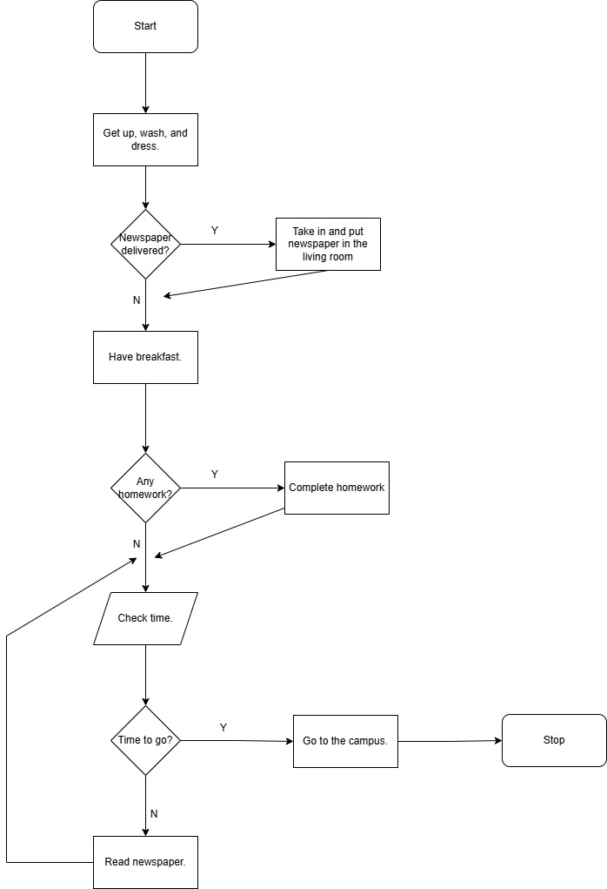

* Exercise 10: Draw a flowchart for one of these activities. Then compare your completed flowchart with other students

Buy item from Tokopedia

-